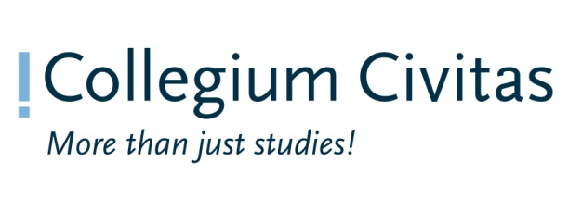
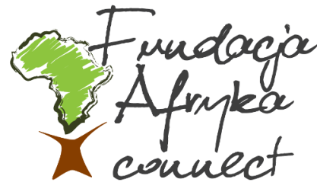

ANNOTATED AGENDA

European Action Week on Racial Discrimination
PREVENTION OF RACISM, XENOPHOBIA AND HATE CRIMES
17.03.2016, Collegium Civitas, Plac.Defilad 1, (12th floor, Aula A)

11.30-12.00 | OPENING SESSION  Opening remarks: James Omolo- Professor Stanisław Mocek Rector of Collegium Civitas  Keynote speech- Prof. Rafal Pankowski (Collegium Civitas i Stowarzyszenie Nigdy Wiecej - Never Again Association)  Technical information (Afryka Connect Foundation)
12.00-13.30 | SESSION 1: Challenges and Perspectives for the Prevention of Racism, hate crime and Xenophobia, and the role of Awareness-Raising Initiatives and Public Discourse  Panelists:  - Draginja Nadazdin- Director Amnesty International.  - Jan Dabkowski- Coordinator of Council of Europe No Hate Speech Movement Campaign in Poland, Young Journalists' Association 'Polis'  - Larry Olomofe- Advisor, tolerance and Hate crime department. Organization for Security and Cooperation in Europe (OSCE)  - Elmi Abdi- Vice President, Somali Foundation  Moderator: James Omolo  This session shall Offer the participants an opportunity to explore current manifestations of racism and xenophobia in Poland, and to discuss current challenges and perspectives regarding their prevention given the prevalence of and contemporary challenges in combating racism and xenophobia in the country. While these are not new phenomena, the challenges confronting them have been compounded by contemporary events. New challenges include the refugee crisis, which has resulted in the increased “scapegoating” of asylum seekers, migrants and other visible minority members, the portrayal of migration as a threat to local populations, the rise of right-wing groups expounding nationalist and xenophobic ideologies. It also offer the opportunity for participants to discuss awareness-raising initiatives in public discourse aimed at combating hate crimes, racism and xenophobia.
13.30-14.30 | COFFEE BREAK & NETWORKING SESSION  Human Library (Żywa Biblioteka) by Aneta Szarfenberg- Rubin Foundation  Human library will simultaneously take place. Sometimes the best way to break down barriers and fight down stereotypes is through a simple conversation. Through a unique travelling library program called the Human Library (Żywa biblioteka), conference participants, will have the opportunity to hear and exchange life stories with others in their communities. The Human Library allows the public to hear first-hand about the experiences of individuals from diverse backgrounds (the “books”) who have faced prejudice and stereotypes in their daily lives. Of course, the books are real people telling real stories. The books in the Human Library are volunteers representing diverse community groups, who are often victims of stereotypes, prejudice or social exclusion. At least 8 different human books will be available to be read for about 10 minutes each.
14.30-15.00  15.00-16.30 | At the beginning of this session will be present a technique called Forum Theatre by Maria Depta - Jędrzejczak, Drama Way  A technique pioneered by Brazilian radical Augusto Boal. A play or scene, usually indicating some kind of oppression, is shown twice. During the replay, any member of the audience (‘spect-actor’) is allowed to shout ‘Stop!’, step forward and take the place of one of the oppressed characters, showing how they could change the situation to enable a different outcome. Several alternatives may be explored by different spect-actors. The other actors remain in character, improvising their responses. A facilitator (Joker) is necessary to enable communication between the players and the audience. The strategy breaks through the barrier between performers and audience, putting them on an equal footing. It enables participants to try out courses of action which could be applicable to their everyday lives. Originally the technique was developed by Boal as a political tool for change (part of the Theatre of the Oppressed), but has been widely adapted for use in educational contexts.  SESSION 2: Promoting tolerance, respect for diversity and non-discrimination through education and media, particularly among the younger generation.  Panelists:  - Wiktor Dynarski -President Fundacja Trans-fuzja, transgender activist.  - Perfait Mpelo-University of European Reional Economy-Jozerow  - Aneta Ołowska-Collegium Civitas  - Senait Cieplinska-Fundacja Adulis  Moderator: Piotr Godzisz  Responsibility for promoting dialogue, tolerance, acceptance of diversity and rejection of intolerance, racism and xenophobia amongst the younger generation is inevitably spread across a wide range of actors. However, the formal education system and the media, including the Internet, both have an enormous role to play. If education is to enable both individuals and society as a whole to develop the skills to address future challenges, it is essential that it promotes tolerance and an appreciation of diversity. In other words, the promotion of respect for each individual’s cultural, religious or ethnic identity within a context of social integration is an indispensable part of the educational process. Some of the issues to be tackled in this section includes but not limited to;  How can students best be exposed to the diversity of their own communities and beyond? What can we learn from school initiatives to promote tolerance through informal activities outside of the normal curriculum? How can acceptance and appreciation of diverse cultures be mainstreamed within media output? How might media, including Internet, be used to promote tolerance and combat the prejudice, ignorance and misunderstanding that contribute to racism, xenophobia, discrimination, anti-Semitism and other forms of intolerance?
16.30 | African traditional dance performance by Uanga Dance School.  Closing of the Meeting.

